Contents

SharePoint 2013: Create an app to access a public OData source 2

Description of the app-scoped external content type sample 2

Prerequisites 3

Key components of the sample 3

Configure the sample 3

Build the sample 3

Run and test the sample 3

Troubleshooting 3

Change log 3

Related content 4

# SharePoint 2013: Create an app to access a public OData source

This documentation is preliminary and is subject to change.

Summary:  Learn how to create an app-scoped external content type and access that data using the Representational State Transfer (REST) API.

## Description of the app-scoped external content type sample

This sample demonstrates how to create an external content type contained within an app for SharePoint, and then surface that data using an external list. The OData source that is used for this sample is the public Northwind OData source located at <http://services.odata.org/Northwind/Northwind.svc>. This OData source is used to create an external list named Customers in the app. Data from the external list is then displayed on the home page of the app by using the RESTful API to query the list. The following image shows the data that will be displayed on the home page of the app.

Figure 1. Data displayed on the home page of the app

The Visual Studio 2012 solution contained in this sample download consists of the following:

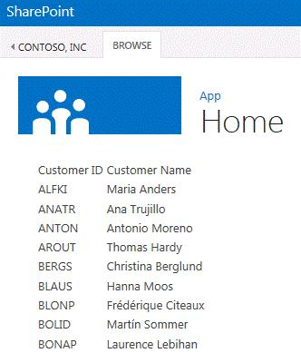

* BCS Module (containing the BDC Metadata Model and External List definition)
* Pages Module (containing the app home page)
* Scripts Module (containing the JavaScript and jQuery code for querying the External List).

## Prerequisites

This sample requires the following:

* A SharePoint 2013 Preview development environment that is configured for app isolation
* Visual Studio 2012
* SharePoint development tools in Visual Studio 2012

## Key components of the sample

The following are included in the sample project:

* A Visual Studio 2012 solution named AppLevelECT, which contains all the required artifacts.

## Configure the sample

Follow these steps to configure the sample.

1. In Visual Studio, select the AppLevelECT project (which is contained in the .zip file that you downloaded from the MSDN Samples Gallery), and change the Site URL property to reference a SharePoint 2013 Preview site where you will deploy the app.
2. In Visual Studio, open the AppLevelODataModel.xml file for editing.
3. Replace all instances of the text “contoso\Domain Users” with the name of a group from the target domain. The group used will be granted rights to use the BDC Metadata Model in the App.

## Build the sample

Press F5 to build and deploy the app.

## Run and test the sample

To run and test the sample:

* Press F5 to build and deploy the app for SharePoint.

Data from the external data list will appear on the home page of the app.

## Troubleshooting

If the app fails to install, ensure that the group referenced in the BDC Metadata Model is correct.

## Change log

First release.

## Related content

* [Business Connectivity Services in SharePoint 2013](http://msdn.microsoft.com/en-us/library/64b7d032-4b83-4e9e-bc08-f0a161af5457)
* Open Data Protocol
* OData: JavaScript Object Notation (JSON) Format
* OData: AtomPub Format